1. Create a static website using HTML5 with semantic elements, forms, tables, audio, video.
<!DOCTYPE html>
<html>
<head>
<title>Static Website</title>

<style>

body{
font-family:Arial;
background:#f0f8ff;
margin:20px;
}

header{
background:#0077b6;
color:white;
padding:15px;
text-align:center;
}

section{
background:white;
padding:20px;
margin-top:20px;
border-radius:10px;
}

table{
width:40%;
border-collapse:collapse;
}

th,td{
border:1px solid gray;
padding:10px;
text-align:center;
width: 33%;
}

button{
background:#0077b6;
color:white;
border:none;
padding:10px;
}

</style>
</head>

<body>

<header>
<h1>Static Website</h1>
</header>

<section>

<h2>Student Form</h2>

<form>

Name:
<input type="text"><br><br>

Email:
<input type="email"><br><br>

<button>Submit</button>

</form>
</section>

<section>

<h2>Student Table</h2>

<table>
<tr>
<th>Name</th>
<th>Age</th>
</tr>
<tr>
<td>Ali</td>
<td>20</td>
</tr>
</table>
</section>

<section>

<h2>Audio & Video</h2>

<audio controls>
<source src="audio.mp3">
</audio>

<br><br>

<video width="300" controls>
<source src="video.mp4">
</video>
</section>

</body>
</html>

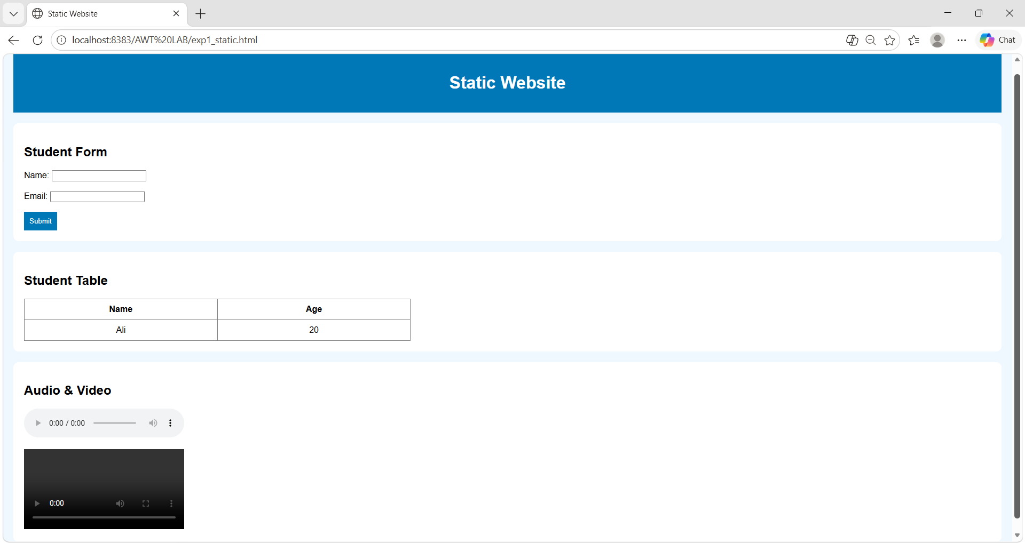

2. Design responsive web pages using CSS3, Flexbox, Grid, and media queries.
<!DOCTYPE html>
<html>
<head>
<title>Responsive Web Page</title>
<style>

body{
font-family:Arial;
background:#f5f5f5;
padding:20px;
}

h2{
text-align:center;
color:#6a1b9a;
}

.container{
display:grid;
grid-template-columns:1fr 1fr 1fr;
gap:20px;
margin-top:20px;
}

.card{
background:white;
padding:20px;
border-radius:10px;
text-align:center;
box-shadow:0 0 10px lightgray;
}
.card img{
width:100%;
height:150px;
border-radius:10px;
}

.card h3{
color:#6a1b9a;
}

.flex{
display:flex;
gap:20px;
margin-top:20px;
}

.item{
flex:1;
background:#ffcc80;
padding:20px;
text-align:center;
border-radius:10px;
font-size:20px;
}

@media(max-width:700px){
.container{
grid-template-columns:1fr;
}
.flex{
flex-direction:column;
}
}
</style>
</head>

<body>
<h2>Responsive Web Design</h2>
<div class="container">
<div class="card">
<img src="https://picsum.photos/300/150?1">
<h3>HTML5</h3>
<p>Semantic structure for web pages.</p>
</div>

<div class="card">
<img src="https://picsum.photos/300/150?2">
<h3>CSS3</h3>
<p>Responsive and attractive styling.</p>
</div>

<div class="card">
<img src="https://picsum.photos/300/150?3">
<h3>JavaScript</h3>
<p>Interactive web page functionality.</p>
</div>

</div>
<div class="flex">
<div class="item">Flexbox Layout</div>
<div class="item">Media Queries</div>
</div>
</body>
</html>

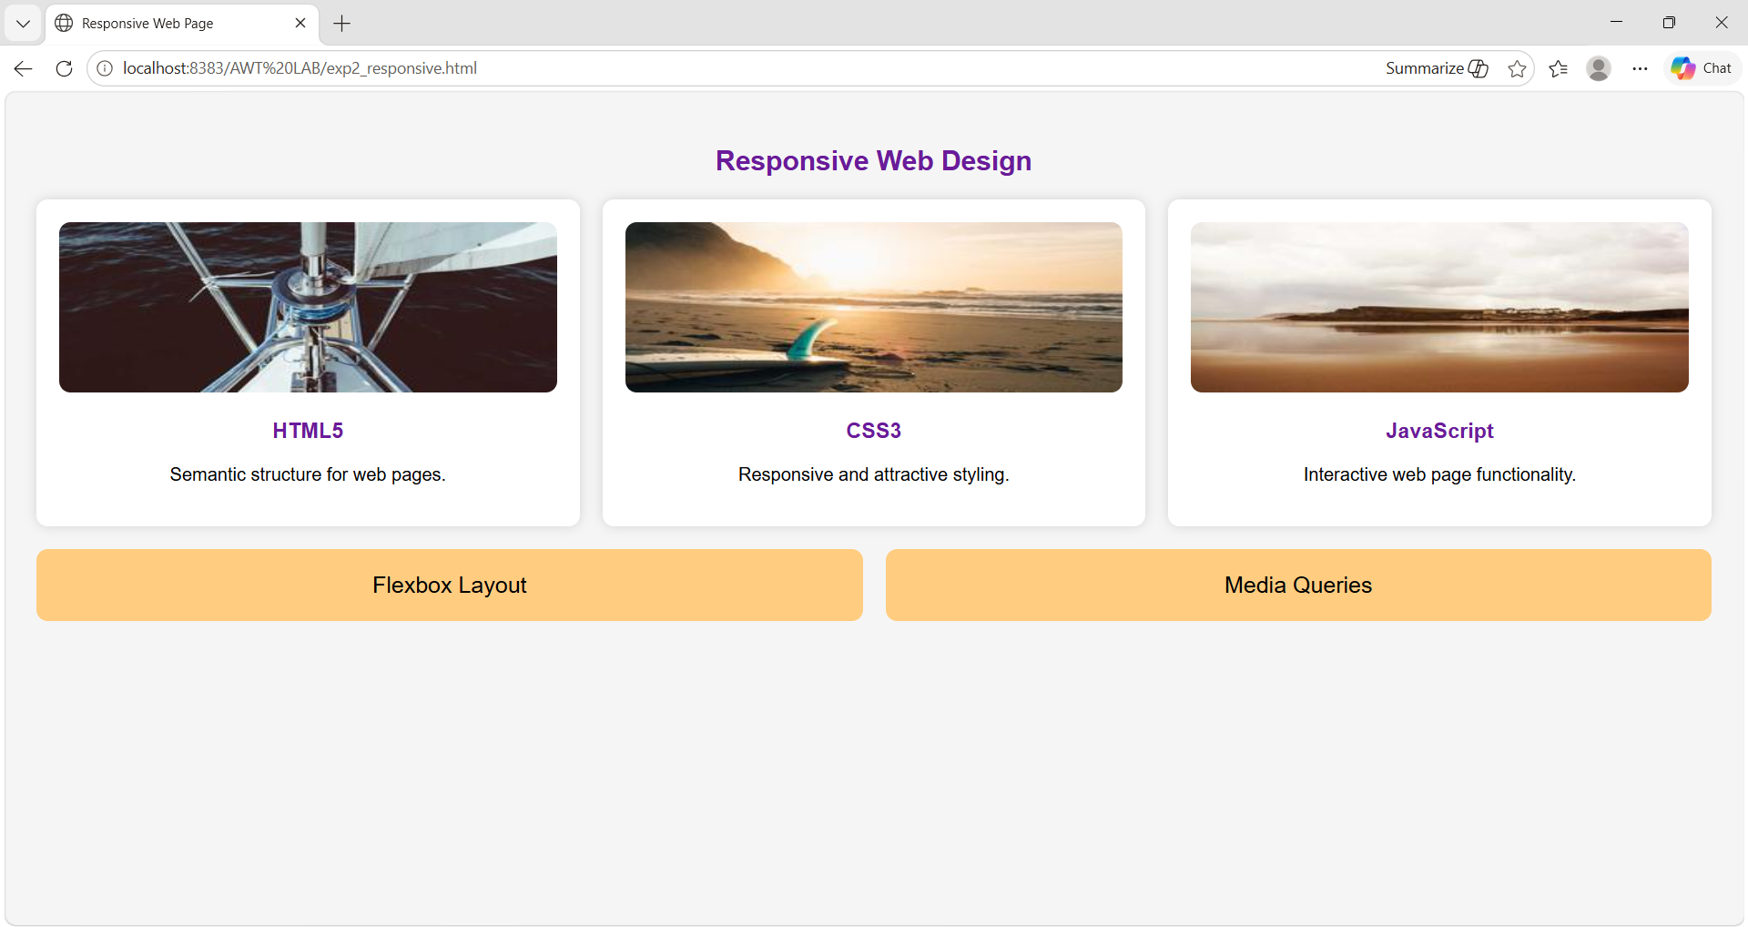

3. Implement client-side validation for forms using JavaScript.
<!DOCTYPE html>
<html>
<head>

<style>

body{
margin-top: 250px;
font-family:Arial;
background:#eef;
}

form{
width:350px;
margin:auto;
background:white;
padding: 20px;
padding-left:20px;
padding-right:40px;
border-radius:10px;
}

input{
width:100%;
padding:8px;
margin-top:5px;
}

button{
background:#0077b6;
color:white;
padding:10px;
border:none;
margin-top:10px;
}
</style>
</head>

<body>

<h2 align="center">
Student Registration
</h2>
<form onsubmit="return validate()">
Name:
<input type="text" id="name"><br><br>
Email:
<input type="text" id="email"><br><br>
Phone:
<input type="text" id="phone"><br><br>
<button>Submit</button>
</form>
<script>

function validate(){
let name=document.getElementById("name").value;
let email=document.getElementById("email").value;
let phone=document.getElementById("phone").value;

if(name==""){
alert("Enter Name");
return false;
}

if(email==""){
alert("Enter Email");
return false;
}

if(phone.length!=10){
alert("Phone number must be 10 digits");
return false;
}

alert("Form Submitted Successfully");
return true;
}
</script>

</body>
</html>
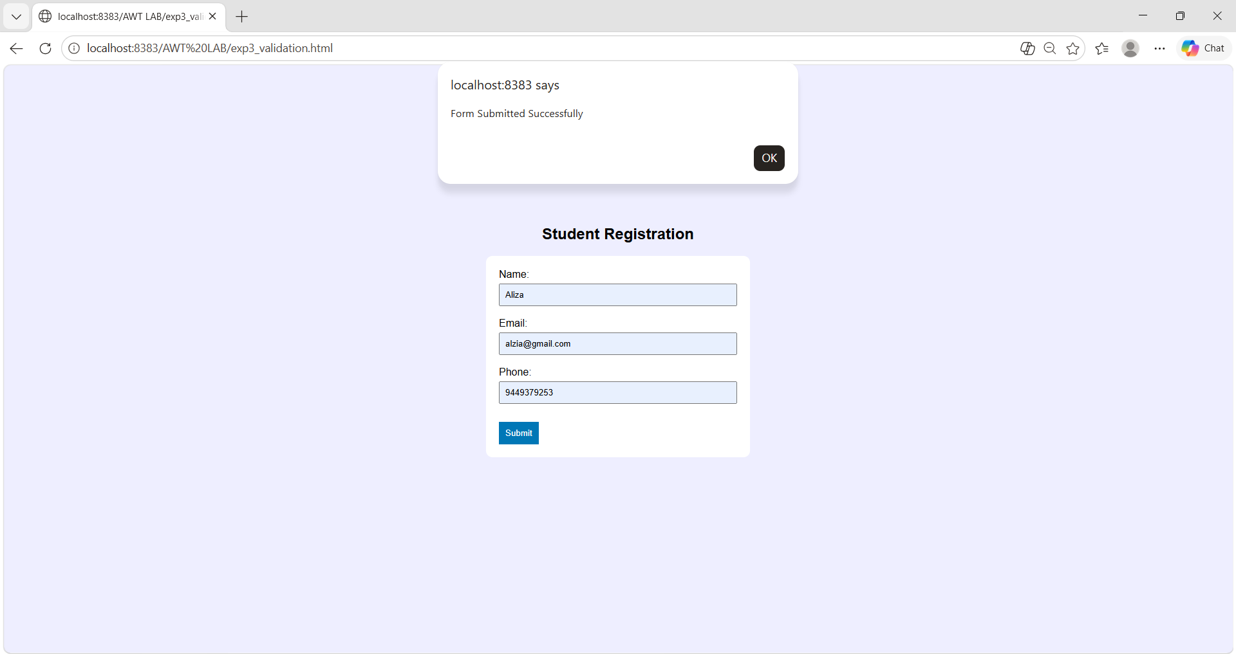

4. Develop interactive web pages using DOM manipulation and event handling.
<!DOCTYPE html>
<html>
<head>

<style>

body{
font-family:Arial;
text-align:center;
background:#eef;
margin-top:80px;
}

.box{
background:white;
width:400px;
margin:auto;
padding:30px;
border-radius:10px;
}

button{
background:#0077b6;
color:white;
border:none;
padding:10px;
margin:5px;
}

</style>
</head>
<body>

<div class="box">
<h1 id="text">Welcome Student</h1>
<img id="image"
src="https://i.pinimg.com/originals/6e/c3/3d/6ec33d23645e624eafa7c509c07de82e.jpg" width="200">
<br><br>
<button onclick="changeText()">
Change Text
</button>

<button onclick="changeColor()">
Change Color
</button>

<button onclick="hideImage()">
Hide Image
</button>
</div>
<script>

function changeText(){
document.getElementById("text").innerHTML=
"Advanced Web Technology";
}

function changeColor(){
document.body.style.background="lightyellow";
}

function hideImage(){
document.getElementById("image").style.display="none";
}
</script>

</body>
</html>

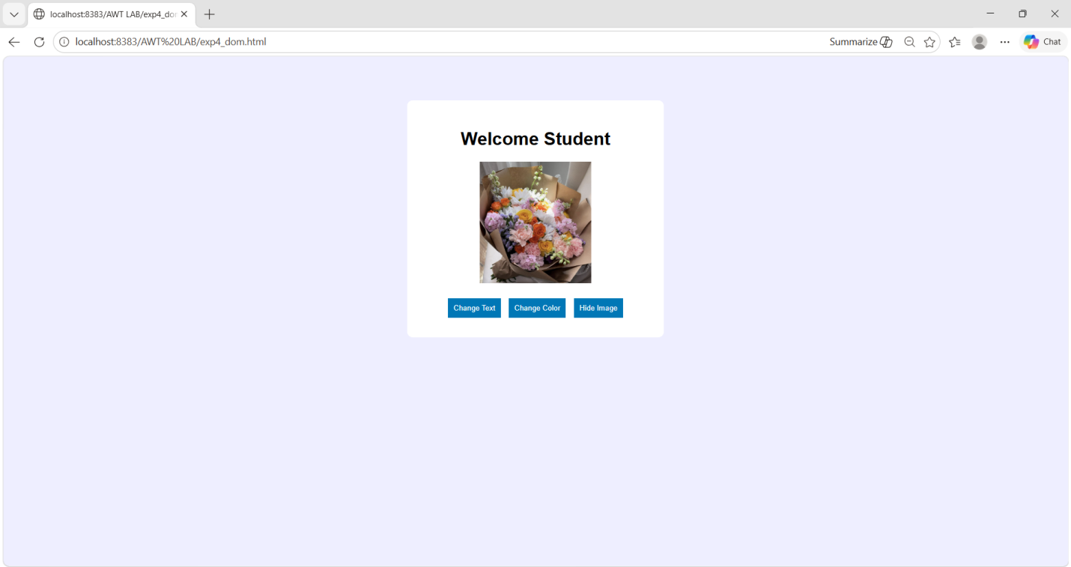

5. Implement ES6 features such as arrow functions, promises, and modules.
<!DOCTYPE html>
<html>
<head>
<title>ES6 Features</title>
<style>

body{
font-family:Arial;
background:#fff3e0;
padding:30px;
}

.box{
width:650px;
margin:auto;
background:white;
padding:20px;
border-radius:10px;
}

h2{
text-align:center;
color:#e65100;
}

div{
background:#fbe9e7;
padding:15px;
margin-top:15px;
border-radius:10px;
}
button{
width:100%;
padding:10px;
background:#e65100;
color:white;
border:none;
font-size:18px;
margin-top:10px;
}

p{
background:white;
padding:10px;
font-size:18px;
}
</style>
</head>

<body>

<div class="box">
<h2>ES6 Features</h2>
<div>
<h3>Arrow Function</h3>
<button onclick="arrow()">Run</button>
<p id="a"></p>
</div>

<div>
<h3>Promise</h3>
<button onclick="promise()">Run</button>
<p id="b"></p>
</div>
<div>
<h3>Module</h3>
<button onclick="module1()">Run</button>
<p id="c"></p>
</div>

<div>
<h3>Spread Operator</h3>
<button onclick="spread()">Run</button>
<p id="d"></p>
</div>

</div>

<script type="module">
export let subject="Advanced Web Technology";
const add=(x,y)=>x+y;
window.arrow=()=>a.innerHTML=
"Addition = "+add(10,20);
window.promise=()=>{
b.innerHTML="Loading...";
new Promise(r=>setTimeout(()=>r("Promise Executed"),1000))
.then(data=>b.innerHTML=data);
}
window.module1=()=>c.innerHTML=
"Module Variable: "+subject;
window.spread=()=>{
let x=[1,2],y=[3,4];
d.innerHTML="Merged Array: "+[...x,...y];
}
</script>
</body>
</html>
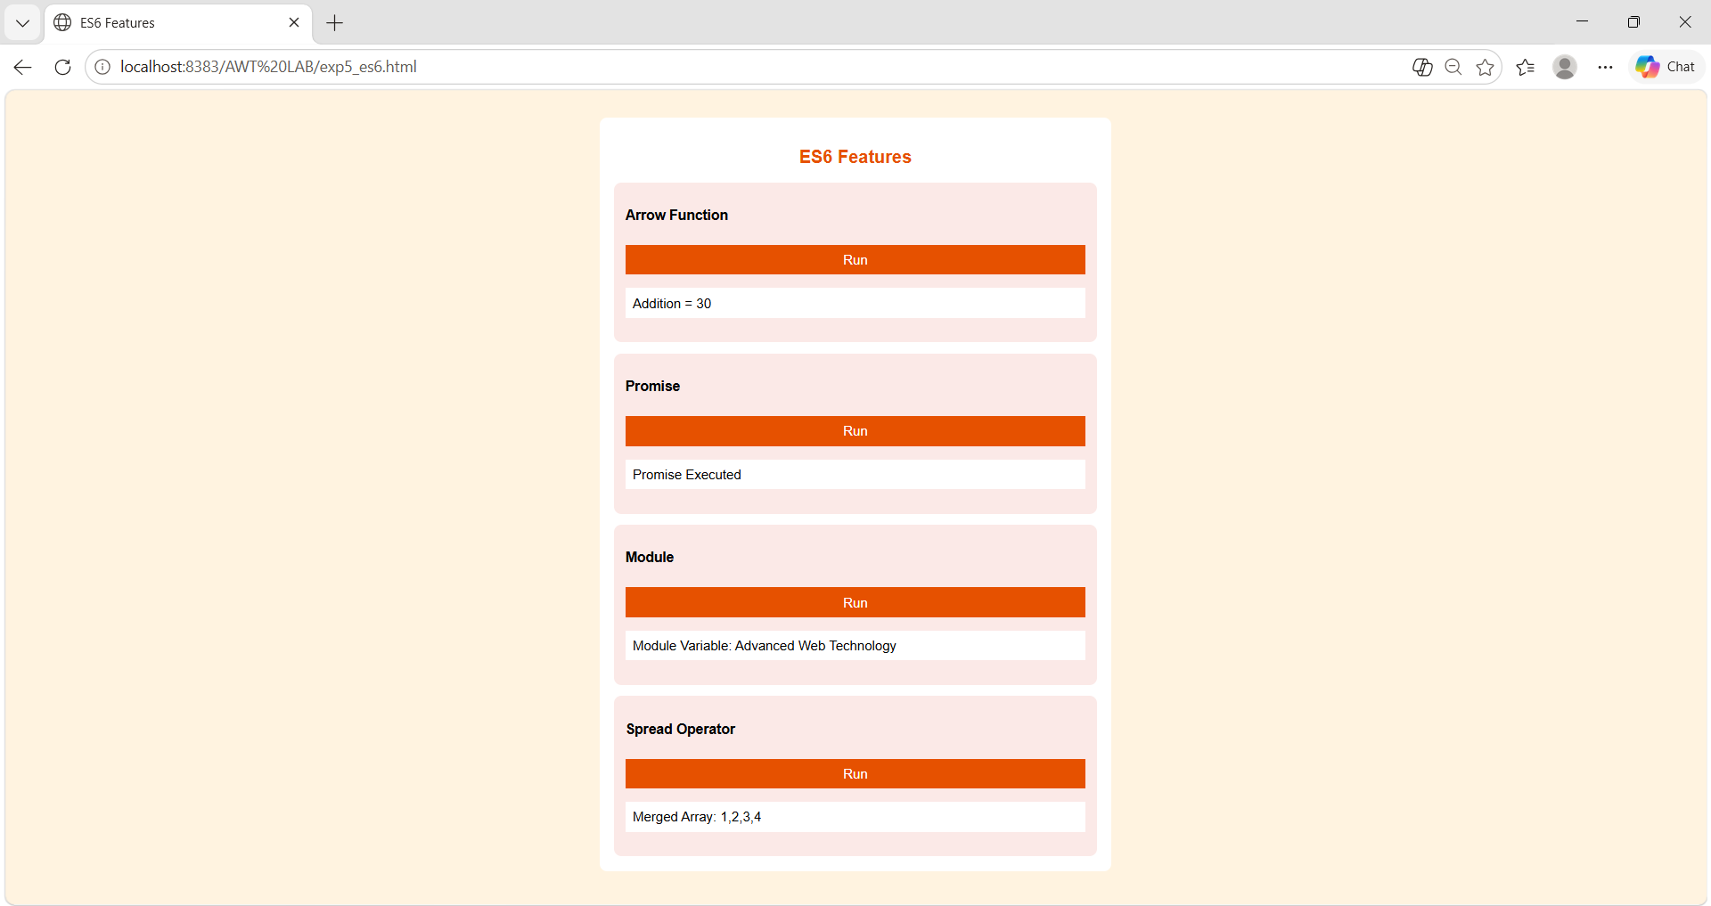

6. Use Fetch API/AJAX to retrieve and display dynamic data.
<!DOCTYPE html>
<html>
<head>
<title>Fetch API</title>
<style>
body{
font-family:Arial;
background:#eef;
padding:20px;
}

.container{
width:400px;
margin:auto;
background:white;
padding:20px;
}

input{
width:100%;
padding:8px;
box-sizing:border-box;
}

button{
background:#0077b6;
color:white;
border:none;
padding:10px;
margin-top:10px;
}

.card{
background:#f4f4f4;
padding:15px;
margin-top:20px;
}

img{
width:100%;
height:180px;
}

</style>
</head>

<body>
<div class="container">
<h2>Country Information</h2>
Enter Country Name:

<input type="text" id="country">
<button onclick="loadCountry()">
Get Details
</button>

<div id="result"></div>
</div>

<script>
function loadCountry(){
let countryName=
document.getElementById("country").value;
fetch("https://restcountries.com/v3.1/name/"+countryName)

.then(response=>response.json())
.then(data=>{
let country=data[0];
document.getElementById("result").innerHTML=

"<div class='card'>" +

"<img src='"+country.flags.png+"'>" +
"<h3>"+country.name.common+"</h3>" +
"<p>Capital: "+country.capital+"</p>" +
"<p>Region: "+country.region+"</p>" +
"<p>Population: "+country.population+"</p>" +
"</div>";
});
}
</script>
</body>
</html>
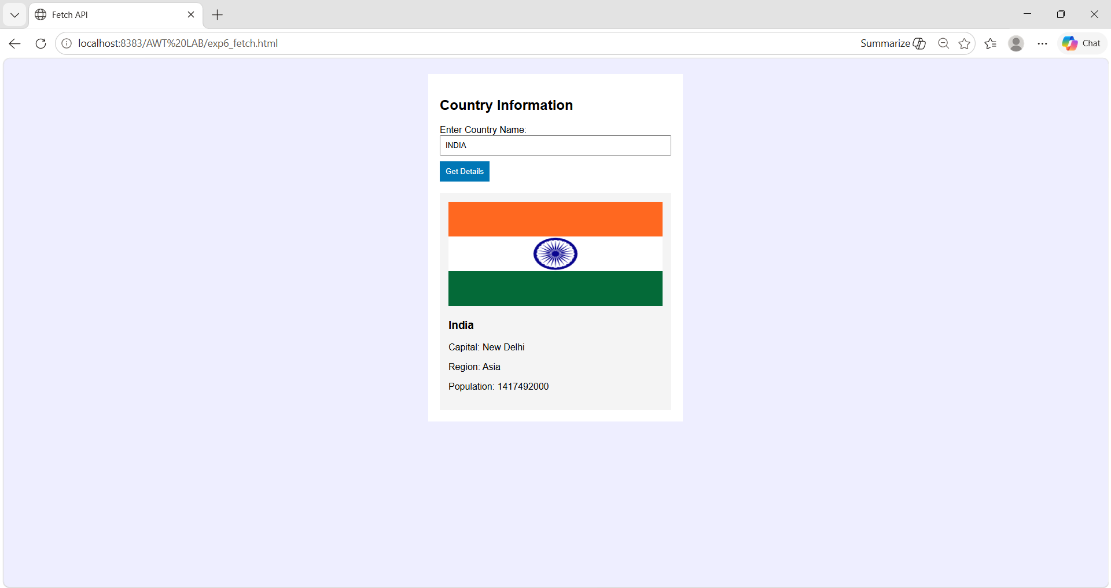

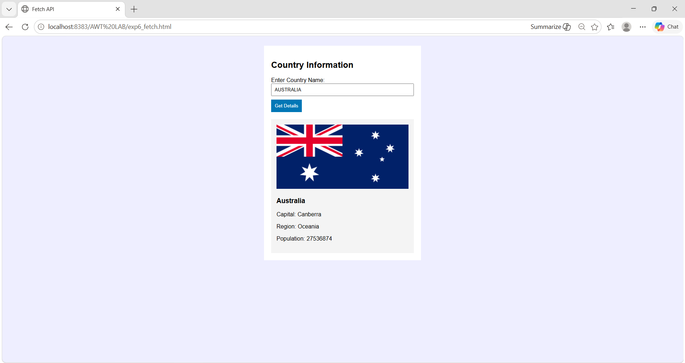

7. Implement client-side storage using Cookies, LocalStorage, and SessionStorage.
<!DOCTYPE html>
<html>
<head>
<title>Client Side Storage</title>
<style>

body{
font-family:Arial;
background:#e3f2fd;
display:flex;
justify-content:center;
align-items:center;
height:100vh;
}

.box{
width:600px;
background:white;
padding:40px;
border-radius:15px;
border:4px solid #42a5f5;
}

h2{
text-align:center;
color:#1565c0;
font-size:42px;
}

label{
font-size:28px;
font-weight:bold;
}

input{
width:100%;
padding:15px;
margin-top:15px;
box-sizing:border-box;
font-size:24px;
border:2px solid #90caf9;
}

button{
width:100%;
padding:15px;
margin-top:15px;
border:none;
color:white;
font-size:22px;
border-radius:8px;
}
.local{background:#43a047;}
.session{background:#fb8c00;}
.cookie{background:#8e24aa;}
.show{background:#1565c0;}

p{
background:#f1f8e9;
padding:20px;
margin-top:25px;
font-size:24px;
border-radius:8px;
}
</style>
</head>

<body>
<div class="box">
<h2>Client Side Storage</h2>
<label>Enter Name:</label>
<input type="text" id="name">

<button class="local" onclick="saveLocal()">
Save to LocalStorage
</button>

<button class="session" onclick="saveSession()">
Save to SessionStorage
</button>

<button class="cookie" onclick="saveCookie()">
Save Cookie
</button>

<button class="show" onclick="showData()">
Show Data
</button>

<p id="output">
Stored data will appear here
</p>
</div>

<script>
function saveLocal(){

let name=document.getElementById("name").value;
localStorage.setItem("username",name);
alert("Saved in LocalStorage");
}

function saveSession(){
let name=document.getElementById("name").value;
sessionStorage.setItem("username",name);
alert("Saved in SessionStorage");
}

function saveCookie(){
let name=document.getElementById("name").value;
document.cookie="username="+name;
alert("Cookie Saved");
}

function showData(){
let local=localStorage.getItem("username");
let session=sessionStorage.getItem("username");
document.getElementById("output").innerHTML=
"LocalStorage: "+local+
"<br><br>SessionStorage: "+session+
"<br><br>Cookies: "+document.cookie;
}
</script>
</body>
</html>
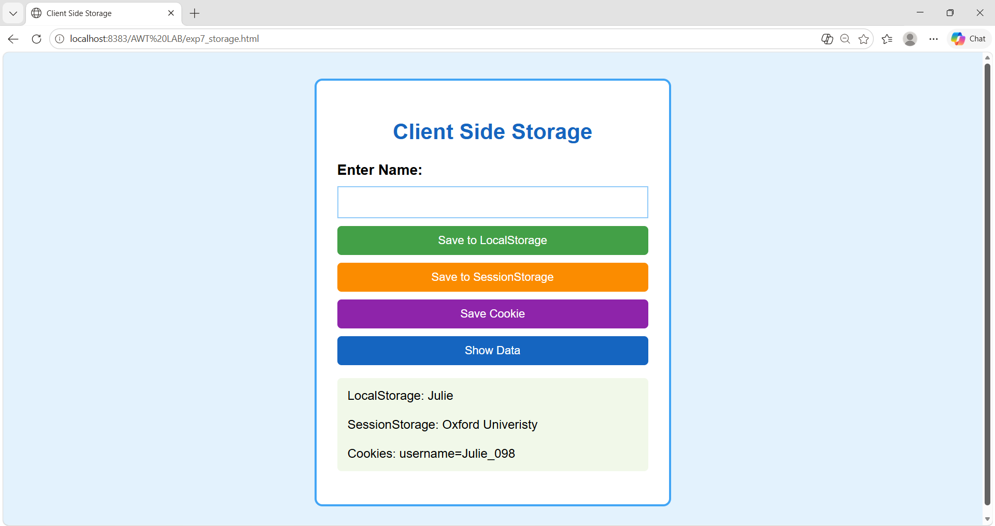

8. Develop server-side scripts to handle GET and POST requests.
Software Requirements
- NetBeans IDE
- Node.js
- Express.js
- Web Browser
PROGRAM
server.js
const express=require("express");
const app=express();
app.use(express.urlencoded({extended:true}));

// GET Request
app.get("/",(req,res)=>{
res.send("<h1 style='color:purple;font-size:40px;text-align:center'>GET Request Successful</h1>");
});

// POST Request
app.post("/submit",(req,res)=>{
res.send("<h1 style='color:green;font-size:40px;text-align:center'>POST Request Received: "+req.body.name+"</h1>");
});

// Server
app.listen(3000,()=>{
console.log("Server Running on Port 3000");
});

index.html
<!DOCTYPE html>
<html>
<head>
<title>GET and POST</title>

<style>
body{
font-family:Arial;
background:#f5f5f5;
text-align:center;
padding:50px;
}

.box{
background:white;
width:400px;
margin:auto;
padding:30px;
border-radius:10px;
}

input,button{
width:90%;
padding:10px;
margin:10px;
font-size:18px;
}

button{
background:#8e44ad;
color:white;
border:none;
}

</style>
</head>

<body>
<div class="box">
<h2>GET and POST Request</h2>
<form action="http://localhost:3000" method="GET">
<button> GET Request </button>
</form>

<form action="http://localhost:3000/submit" method="POST">
<input type="text" name="name" placeholder="Enter Name">
<button> POST Request </button>
</form>
</div>
</body>
</html>

PROCEDURE / EXECUTION STEPS
Step 1:
Open NetBeans IDE and create a project named:
AWT LAB
Inside the Site Root folder, create two files:
server.js
index.html
Write the Node.js Express code in server.js and the HTML code in index.html.

Step 2:
Open the project folder location in File Explorer and open the: public_html folder.
Click on the address bar, type:
cmd
and press Enter to open Command Prompt in the same folder.

Step 3:
Initialize the Node.js project and install Express.js using:
npm init -y
npm install express

Step 4:
Run the server using: node server.js
The terminal displays: Server Running on Port 3000

Step 5:
Go back to NetBeans, right-click on: index.html and select: Run File
Browser opens automatically.
Click on the: GET Request button.
Output displayed:
GET Request Successful
Enter a name in the textbox.
Example: Department of CSE
Click on the: POST Request button.
Output displayed:
POST Request Received: Department of CSE
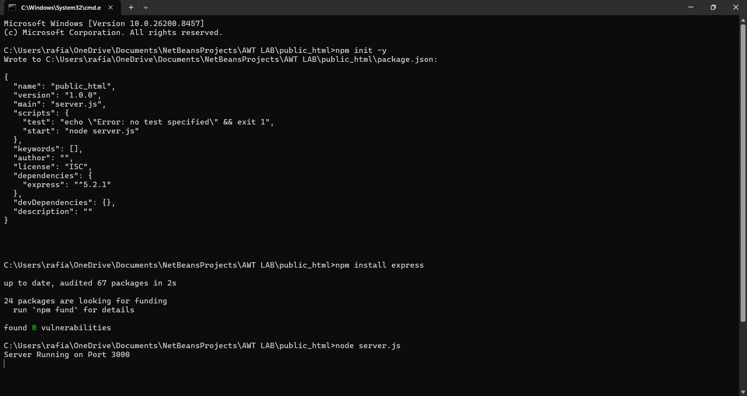

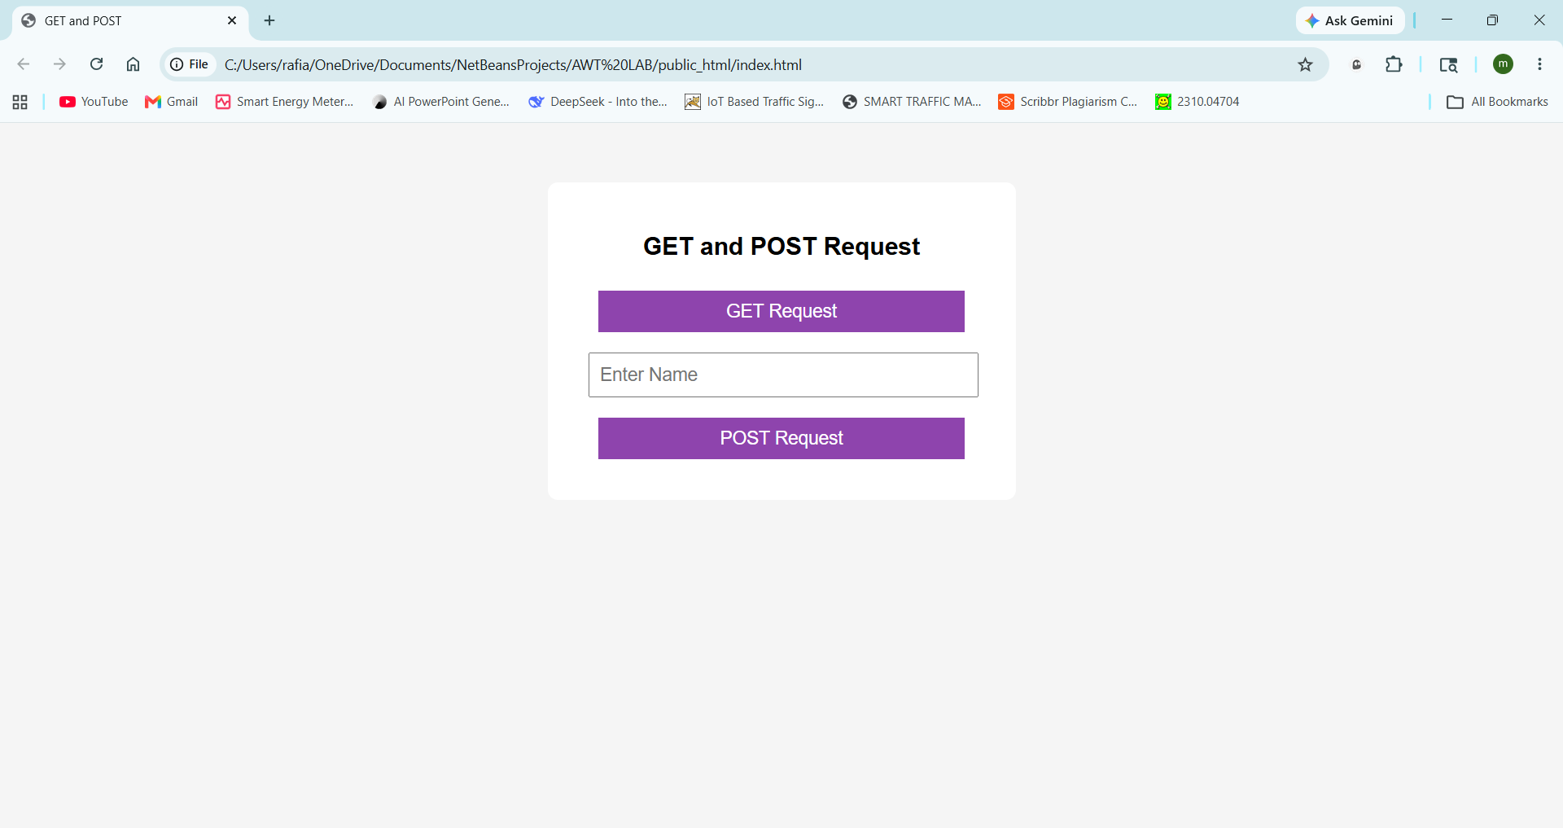
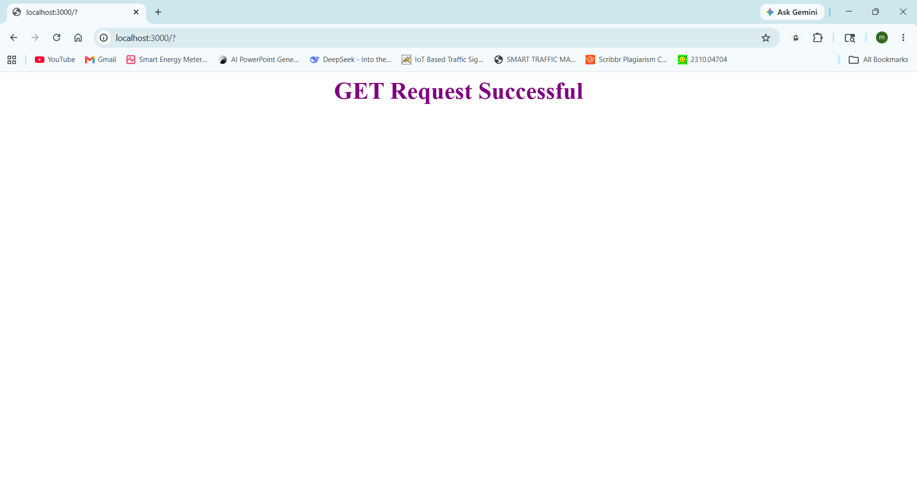

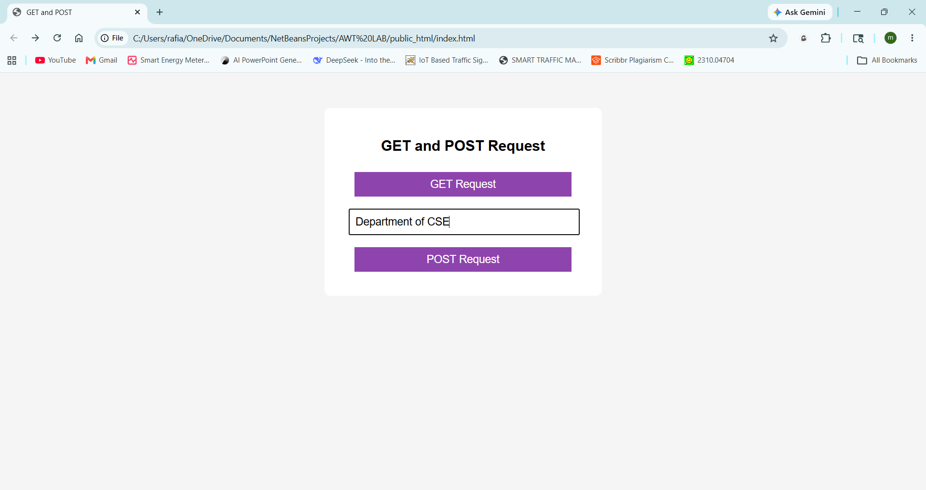

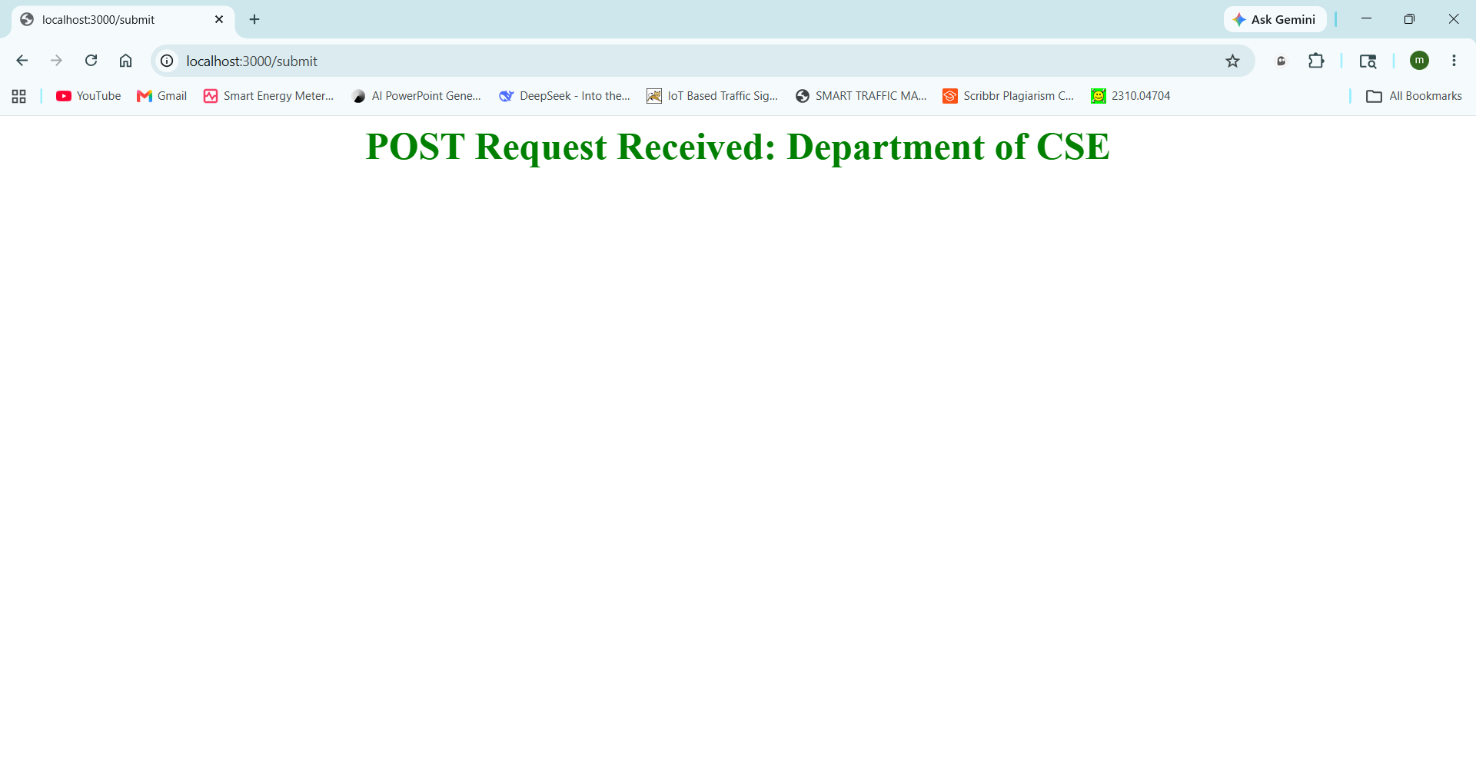
9. Design and connect a database (MySQL/MongoDB) to perform CRUD operations.
Software Requirements
MySQL Server
MySQL Workbench
Installation of MySQL
- Download and install MySQL Server and MySQL Workbench from the MySQL official website.
- Configure the root user account and password during installation.
- Launch MySQL Workbench and connect to the local MySQL server to execute SQL queries.
Procedure
Step 1: Create Database
Query:
CREATE DATABASE CollegeDB;
Output: Database created successfully.
Step 2: Select Database
Query:
USE CollegeDB;
Output: Database changed.
Step 3: Create Student Table
Query:
CREATE TABLE Student (
USN VARCHAR(15) PRIMARY KEY,
Student_Name VARCHAR(50),
Department VARCHAR(30),
Semester INT,
CGPA DECIMAL(3,2),
Email VARCHAR(50)
);
Output: Table created successfully.
CREATE Operation
Example 1: Insert First Student Record
Query:
INSERT INTO Student
VALUES ('25KB02MTS01',
'Aliza Mahvash', 'Computer Science', 2, 8.75, 'aliza@gmail.com');
Output: 1 row inserted.
Example 2: Insert Second Student Record
Query:
INSERT INTO Student
VALUES ('25KB02MTS02', 'Ayesha Khan', 'Computer Science', 2, 9.10, 'ayesha@gmail.com');
Output: 1 row inserted.
READ Operation
Example 1: Display All Student Records
Query:
SELECT * FROM Student;
Output:
USN | Student_Name | Department | Semester | CGPA | Email
25KB02MTS01 | Aliza Mahvash | Computer Science | 2 | 8.75 | aliza@gmail.com
25KB02MTS02 | Ayesha Khan | Computer Science | 2 | 9.10 | ayesha@gmail.com

Example 2: Display Students of Computer Science Department
Query:
SELECT * FROM Student
WHERE Department='Computer Science';
Output: Both student records are displayed.
UPDATE Operation
Example 1: Update Student CGPA
Query:
UPDATE Student
SET CGPA = 9.20
WHERE USN = '25KB02MTS01';
Output: 1 row updated.
Example 2: Verify Updated Record
Query:
SELECT * FROM Student
WHERE USN='25KB02MTS01';
Output:
USN | Student_Name | Department | Semester | CGPA | Email
25KB02MTS01 | Aliza Mahvash | Computer Science | 2 | 9.20 | aliza@gmail.com

DELETE Operation
Example 1: Delete Student with USN 25KB02MTS02
Query:
DELETE FROM Student
WHERE USN = '25KB02MTS02';
Output: 1 row deleted.
Example 2: Delete Student with USN 25KB02MTS01
Query:
DELETE FROM Student
WHERE USN = '25KB02MTS01';
Output: 1 row deleted.
Verification
Query:
SELECT * FROM Student;
Output: Empty set (0 rows).

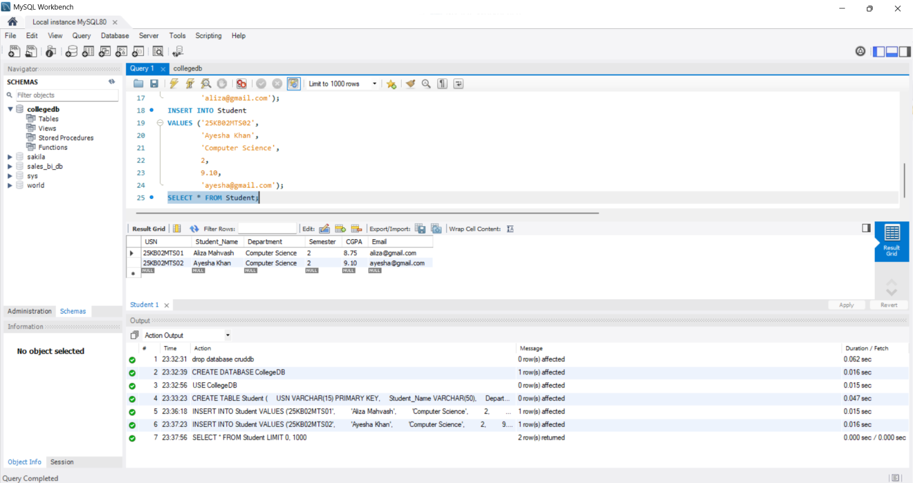

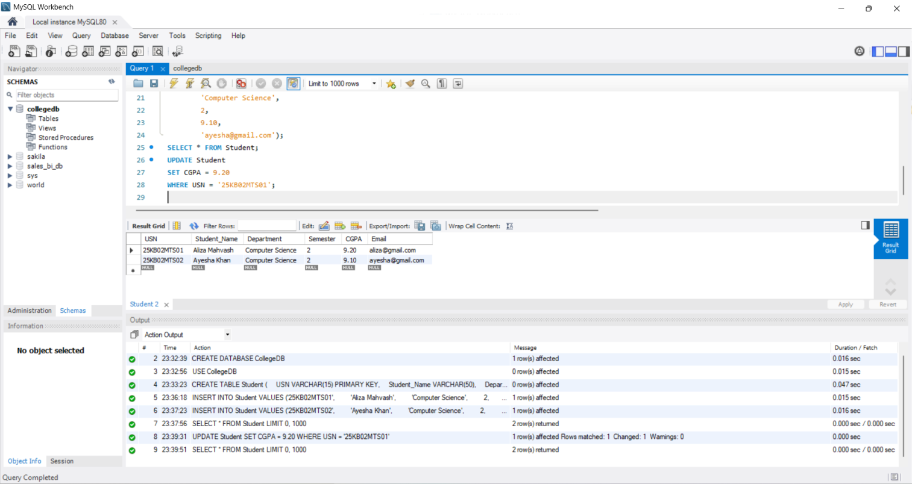

10. Develop RESTful APIs for a Simple Application.

Software Requirements
• NetBeans IDE
• Node.js
• Express.js
• Web Browser

PROGRAM
api.js

const express=require("express");
const app=express();
app.use((req,res,next)=>{
res.header("Access-Control-Allow-Origin","*");
res.header("Access-Control-Allow-Headers","*");
res.header("Access-Control-Allow-Methods","GET,POST,DELETE");
next();
});

app.use(express.json());

let students=[
{id:1,name:"Aliza"}
];

// GET
app.get("/students",(req,res)=>{
res.json(students);
});

// POST
app.post("/students",(req,res)=>{
let newStudent={

id:students.length+1,
name:req.body.name
};

students.push(newStudent);
res.json(students);
});

// DELETE
app.delete("/students/:id",(req,res)=>{
let id=parseInt(req.params.id);
students=students.filter(s=>s.id!==id);
res.json(students);
});

app.listen(3000,()=>{
console.log("REST API Running on Port 3000");
});

index.html

<!DOCTYPE html>
<html>
<head>
<title>REST API Demo</title>

<style>

body{
font-family:Arial;
background:#fff8e1;
text-align:center;
padding:50px;
}

.box{
background:white;
width:500px;
margin:auto;
padding:25px;
border-radius:10px;
border:3px solid #ff9800;
}

h2{
color:#e65100;
}

input,button{
width:90%;
padding:10px;
margin:10px;
font-size:18px;
}

button{
background:#ff9800;
color:white;
border:none;
cursor:pointer;
}

p{
font-size:18px;
font-weight:bold;
word-wrap:break-word;
}

</style>
</head>
<body>

<div class="box">
<h2>REST API Testing</h2>
<input type="text" id="name" placeholder="Enter Name">
<input type="number" id="id" placeholder="Enter ID to Delete">
<button onclick="getData()">GET</button>
<button onclick="postData()">POST</button>
<button onclick="deleteData()">DELETE</button>
<p id="output"></p>
</div>

<script>

function getData(){
fetch("http://localhost:3000/students")
.then(res=>res.json())
.then(data=>{
document.getElementById("output").innerHTML=
JSON.stringify(data);
});
}

function postData(){
let name=document.getElementById("name").value;
fetch("http://localhost:3000/students",{
method:"POST",
headers:{
"Content-Type":"application/json"
},
body:JSON.stringify({name:name})
})

.then(res=>res.json())
.then(data=>{
document.getElementById("output").innerHTML=
JSON.stringify(data);
});
}

function deleteData(){
let id=document.getElementById("id").value;
fetch("http://localhost:3000/students/"+id,{
method:"DELETE"
})
.then(res=>res.json())
.then(data=>{
document.getElementById("output").innerHTML=
JSON.stringify(data);
});
}

</script>

</body>
</html>

PROCEDURE / EXECUTION STEPS

Step 1:
Open NetBeans IDE and create a project named:
AWT LAB
Inside the Site Root folder, create two files:
api.js
index.html
Write the Node.js REST API code in api.js and the HTML code in index.html.

Step 2:
Open the project folder location in File Explorer and open the public_html folder.
Click on the address bar, type: cmd and press Enter to open Command Prompt in the same folder.
Step 3:
Initialize the Node.js project and install Express.js using:
npm init -y
npm install express

Step 4:
Run the REST API server using: node api.js
The terminal displays:
REST API Running on Port 3000

Step 5:
Go back to NetBeans, right-click on:
index.html
Select:
Run File
The browser opens automatically.

• Click GET button to retrieve all student records.
• Enter a name and click POST button to add a new student.
• Enter a Student ID and click DELETE button to remove a student record.

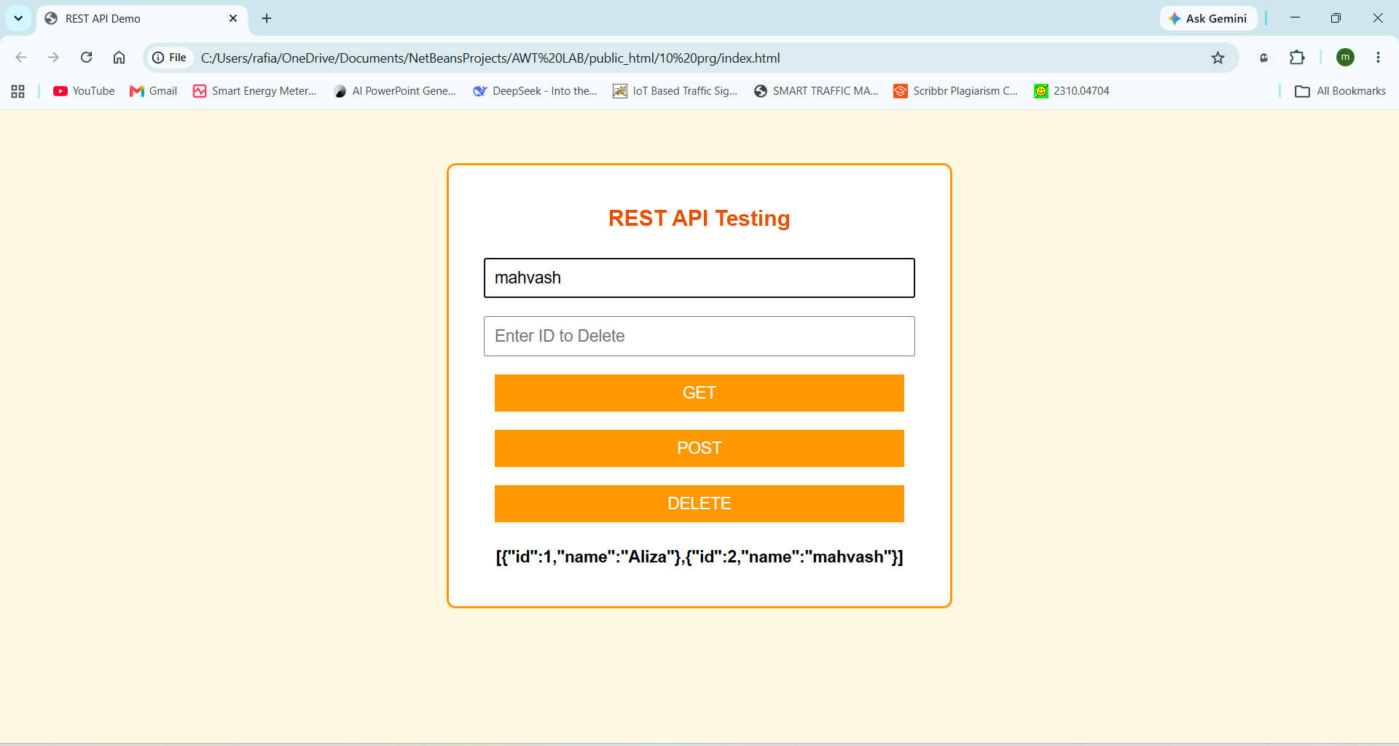
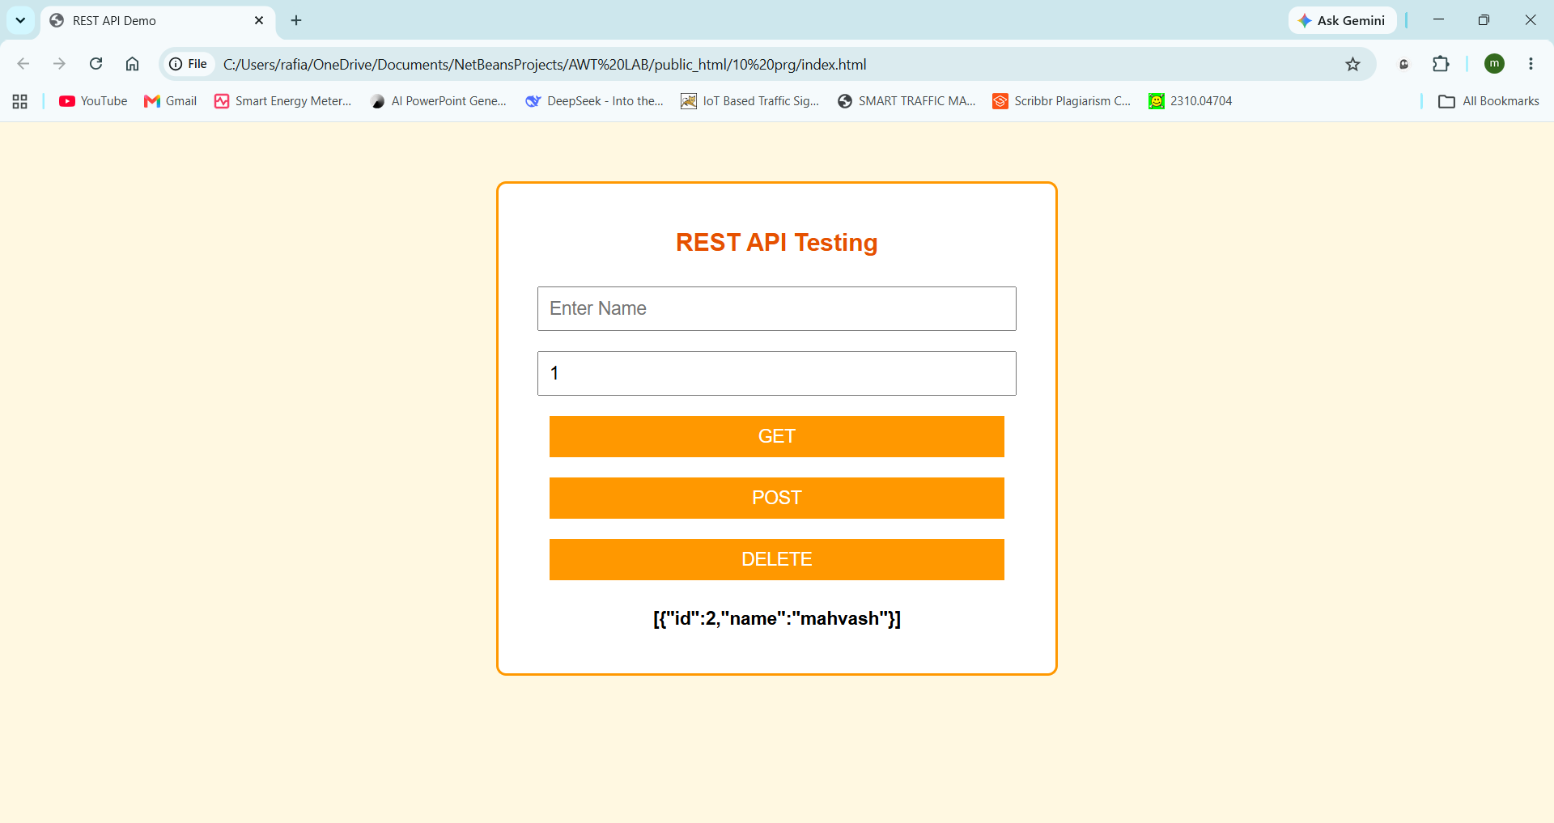
11. Version Control Using Git and GitHub. Deploy a Simple Web Application
Software Requirements
• NetBeans IDE
• Git
• GitHub Account
• Web Browser

PROCEDURE / EXECUTION STEPS

Step 1:
Install Git from the Git website and create a GitHub account.

Step 2:
Open NetBeans IDE and open the project folder:
AWT LAB
Ensure all experiment files are available inside the public_html folder.

Step 3:
Open the public_html folder in File Explorer.
Click on the address bar, type: cmd and press Enter to open Command Prompt in the project folder.
Step 4:
Initialize the Git repository using:
git init

Output: Initialized empty Git repository

Step 5:
Add all project files to Git using:
git add .
Verify the files using:
git status
All project files will appear under:
Changes to be committed

Step 6:
Create the first commit using:
git commit -m "First Commit"

Output: [master (root-commit)] First Commit

Step 7:
Login to GitHub and create a new repository named:
awt-lab
Select Public Repository and click Create Repository.

Step 8:
Connect the local repository to GitHub using:
git remote add origin https://github.com/Aliza-15/awt-lab.git
git branch -M main
git push -u origin main
Authorize Git Credential Manager when prompted.

Step 9:
After successful upload, verify that all project files are visible in the GitHub repository.

Step 10:
Deploy the project using GitHub Pages.
Open:
Repository → Settings → Pages
Under Build and Deployment:
Select:
Source → Deploy from a branch
Choose:
Branch → main
Folder → /(root)
Click: Save

Step 11:
Wait for deployment to complete.
GitHub generates a live website URL:
https://aliza-15.github.io/awt-lab/
Open the URL in the browser to verify the deployment.
